SIMATS ENGINEERING

Department of Computer Science & Engineering

ASSESSMENT TOOL 1- EXPERIMENTS

Course Code: | CSA12 | Course Title: | Computer Architecture
CO Assessed: | CO3 | Assessment: | ASSESSMENT TOOL 1-EXPERIMENTS
Weightage: | 45% | Total Marks: | 25
CO3 Statement: | Register transfers, Arithmetic and logic operations. Multiple Bus Organization: Data transfer among multiple buses. Pipelining: Stages of pipelining, Pipeline performance, hazards (data, instruction). (BL3)
Student Name: | S Prithika | Reg.No.: | 192512432
Department: | BE ECE | Date: | 18/8/26

ANNEXURE A

Experiment | Question
1 | Design and implement a Register Transfer Unit (RTU) to demonstrate data transfer between registers. Perform operations such as R2 ← R1, R3  ←R1 + R2, and R4 ← R3. Verify the contents of registers after each  transfer.
2 | Design and implement an Arithmetic and Logic Unit (ALU) to perform arithmetic operations such as addition and subtraction and logical operations such as AND, OR, XOR, and NOT. Display and verify the  output for different input combinations.
3 | Implement a Multiple Bus Organization for a CPU data path. Demonstrate the transfer of data among registers through multiple buses and perform an arithmetic operation using the ALU. Verify the register  contents after each operation.
4 | Design and simulate a 4-stage instruction pipeline consisting of Instruction Fetch (IF), Instruction Decode (ID), Execute (EX), and Write Back (WB). Demonstrate the execution of multiple instructions  simultaneously and calculate the pipeline speedup.
5 | Implement and analyze pipeline hazards using a set of dependent instructions. Demonstrate data hazards and instruction hazards, and apply appropriate techniques such as stalling, forwarding, or branch handling to resolve them. Compare the pipeline performance before and  after hazard resolution.

Note: use Logisim

1. Register Transfer Unit (RTU)
Aim
To design and implement a Register Transfer Unit to demonstrate data transfer between registers and verify the register contents after each operation.
Operations
  - R2 ← R1
  - R3 ← R1 + R2
  - R4 ← R3 Verilog Code module RTU;
reg [7:0] R1, R2, R3, R4;
initial begin
// Initial values R1 = 8'd10; R2 = 8'd0;
R3 = 8'd0; R4 = 8'd0;
$display("Initial: R1=%d R2=%d R3=%d R4=%d", R1,R2,R3,R4);
// R2 <- R1 R2 = R1;
$display("After R2 <- R1: R1=%d R2=%d R3=%d R4=%d", R1,R2,R3,R4);
// R3 <- R1 + R2 R3 = R1 + R2;
$display("After R3 <- R1 + R2: R1=%d R2=%d R3=%d R4=%d", R1,R2,R3,R4);
// R4 <- R3 R4 = R3;
$display("After R4 <- R3: R1=%d R2=%d R3=%d R4=%d", R1,R2,R3,R4);
$finish; end

endmodule Expected Output
Operation | R1 | R2 | R3 | R4
Initial | 10 | 0 | 0 | 0
R2 ← R1 | 10 | 10 | 0 | 0

Operation R1 R2 R3 R4
R3 ← R1 + R2 | 10 | 10 | 20 | 0
R4 ← R3 | 10 | 10 | 20 | 20
Result
The Register Transfer Unit successfully performs the required register transfers and arithmetic operation. The final contents are:
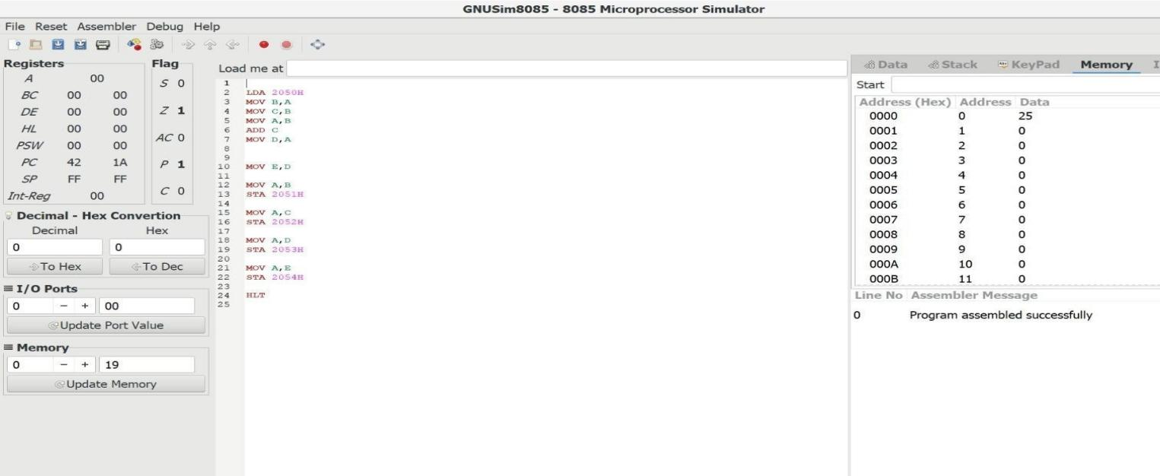
R1 = 10, R2 = 10, R3 = 20, R4 = 20.

Arithmetic and Logic Unit (ALU)
Aim
To design and implement an ALU that performs arithmetic operations such as addition and subtraction and logical operations such as AND, OR, XOR, and NOT.
Operations
Opcode | Operation
000 | Addition
001 | Subtraction
010 | AND
011 | OR
100 | XOR
101 | NOT A
Verilog Code module ALU;
reg [7:0] A, B;
reg [2:0] OP;
reg [7:0] Y;
always @(*) begin case(OP)
3'b000: Y = A + B;
3'b001: Y = A - B;
3'b010: Y = A & B;
3'b011: Y = A | B;

3'b100: Y = A ^ B;
3'b101: Y = ~A;
default: Y = 8'b00000000; endcase
end
initial begin
A = 8'b00001111; // 15
B = 8'b00000011; // 3
OP = 3'b000; #10;
$display("ADD : %d", Y);
OP = 3'b001; #10;
$display("SUB : %d", Y);
OP = 3'b010; #10;
$display("AND : %d", Y);
OP = 3'b011; #10;
$display("OR : %d", Y);
OP = 3'b100; #10;
$display("XOR : %d", Y);
OP = 3'b101; #10;
$display("NOT : %d", Y);
$finish; end

endmodule Expected Output For:
o A = 15 = 00001111
o B = 3 = 00000011
Operation | Result
A + B | 18
A - B | 12
A AND B | 3
A OR B | 15
A XOR B | 12
NOT A | 240
NOT A = 11110000 = 240 for an 8-bit ALU.
Result
The ALU successfully performs addition, subtraction, AND, OR, XOR, and NOT

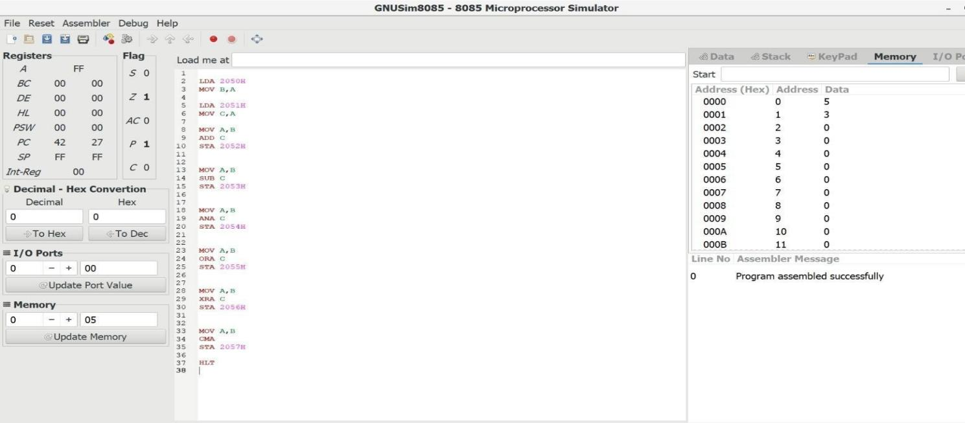
operations for the given input combinations.

Multiple Bus Organization
Aim
To implement a multiple-bus organization for a CPU datapath, demonstrate data transfer between registers through multiple buses, and perform an arithmetic operation using the ALU.
Basic Organization
A simple three-bus datapath consists of:
  - Bus A → carries first ALU operand
  - Bus B → carries second ALU operand
  - Bus C → carries ALU result back to a register Example operation:
R3 ← R1 + R2
The operation occurs as:
R1 ──> Bus A ──┐
│
▼
ALU ───> Bus C ───> R3
▲
│
R2 ──> Bus B ──┘ Verilog Code
module Multiple_Bus;

reg [7:0] R1, R2, R3, R4;
reg [7:0] BusA, BusB, BusC; initial begin
// Load registers R1 = 8'd15;
R2 = 8'd5;

R3 = 8'd0; R4 = 8'd0;
$display("Initial: R1=%d R2=%d R3=%d R4=%d", R1,R2,R3,R4);
// R1 -> Bus A BusA = R1;
// R2 -> Bus B BusB = R2;
// ALU addition
BusC = BusA + BusB;
// Bus C -> R3 R3 = BusC;
$display("After R3 <- R1 + R2:");
$display("R1=%d R2=%d R3=%d R4=%d", R1,R2,R3,R4);
// R3 -> R4 BusA = R3; R4 = BusA;
$display("After R4 <- R3:");
$display("R1=%d R2=%d R3=%d R4=%d", R1,R2,R3,R4);

$finish; end

endmodule Expected Output
Operation | R1 | R2 | R3 | R4
Initial | 15 | 5 | 0 | 0
R3 ← R1 + R2 | 15 | 5 | 20 | 0
R4 ← R3 | 15 | 5 | 20 | 20
Result
The multiple-bus CPU datapath successfully transfers data through Bus A, Bus B, and Bus
C. The ALU performs the addition and stores the result in R3. Final values: R1 = 15, R2 = 5, R3 = 20, R4 = 20.

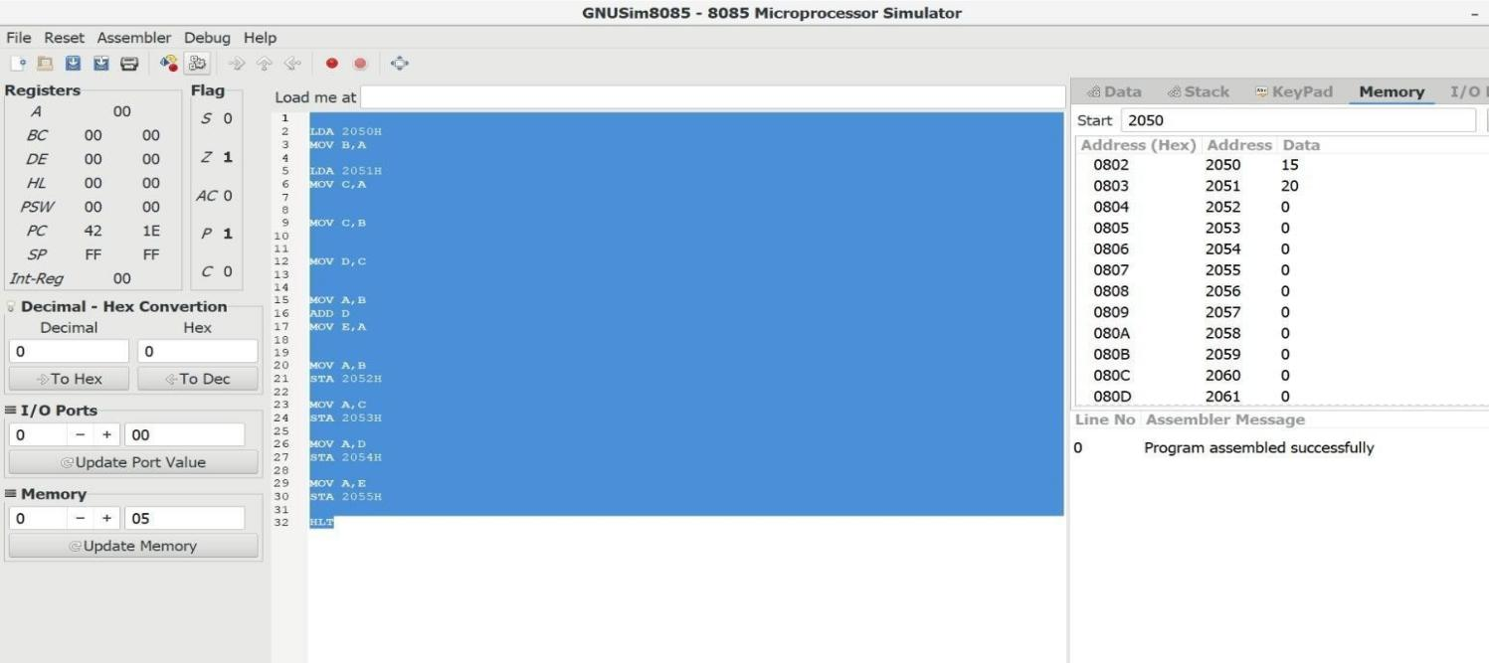

Four-Stage Instruction Pipeline
Aim
To design and simulate a four-stage instruction pipeline consisting of:
- IF – Instruction Fetch
- ID – Instruction Decode
- EX – Execute
- WB – Write Back
and calculate the pipeline speedup. Pipeline Stages
IF → ID → EX → WB
Consider four instructions:
I1 I2 I3 I4
Pipeline Timing
Cycle | I1 | I2 | I3 | I4
1 | IF
2 | ID | IF
3 | EX | ID | IF
4 | WB | EX | ID | IF
5 |  | WB | EX | ID
6 |  |  | WB | EX
7 |  |  |  | WB
Therefore, 4 instructions require 7 cycles using the pipeline. Non-Pipelined Execution
Without pipelining, each instruction requires 4 stages: 4 instructions × 4 stages = 16 cycles
Pipelined Execution
For n instructions and k stages:
𝑇𝑝𝑖𝑝𝑒𝑙𝑖𝑛𝑒 = 𝑘 + (𝑛 − 1)

For k = 4 and n = 4: Speedup

𝑇 = 4 + (4 − 1) = 7 𝑐𝑦𝑐𝑙𝑒𝑠
𝑝𝑖𝑝𝑒𝑙𝑖𝑛𝑒

𝑇
𝑆𝑝𝑒𝑒𝑑𝑢𝑝 = 𝑛𝑜𝑛−𝑝𝑖𝑝𝑒𝑙𝑖𝑛𝑒
𝑇
𝑝𝑖𝑝𝑒𝑙𝑖𝑛𝑒
𝑆𝑝𝑒𝑒𝑑𝑢𝑝 = ¹⁶
7
𝑆𝑝𝑒𝑒𝑑𝑢𝑝 = 2. 286

So the pipeline gives approximately 2.29× speedup for four instructions.
Simple Verilog Simulation module Pipeline;

integer cycle; initial begin
$display("Cycle\tIF\tID\tEX\tWB");
for(cycle = 1; cycle <= 7; cycle = cycle + 1) begin case(cycle)
1: $display("1\tI1\t-\t-\t-");
2: $display("2\tI2\tI1\t-\t-");
3: $display("3\tI3\tI2\tI1\t-");
4: $display("4\tI4\tI3\tI2\tI1");
5: $display("5\t-\tI4\tI3\tI2");
6: $display("6\t-\t-\tI4\tI3");
7: $display("7\t-\t-\t-\tI4"); endcase

end

$finish; end

endmodule Result
The four-stage pipeline successfully executes multiple instructions simultaneously. For four instructions, execution time is reduced from 16 cycles to 7 cycles, giving a speedup of approximately 2.29×.

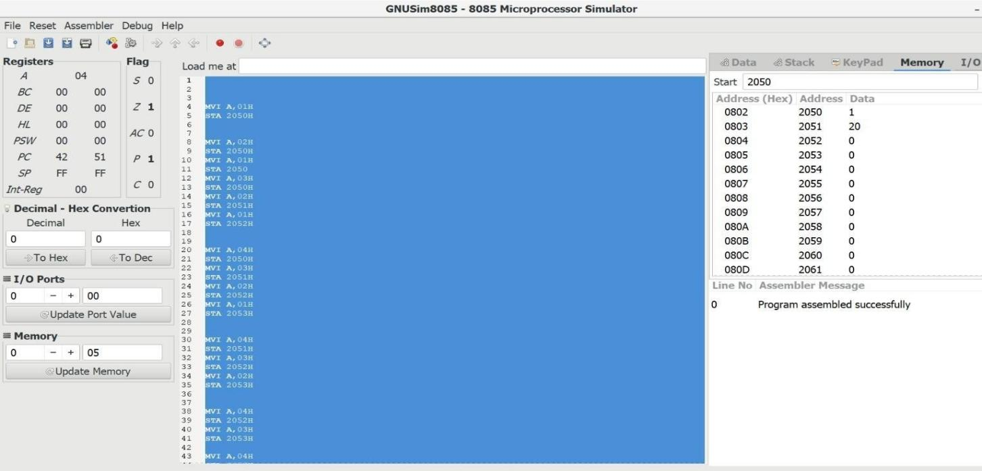

Pipeline Hazards and Hazard Resolution
Aim
To implement and analyze pipeline hazards using dependent instructions and demonstrate techniques such as stalling, forwarding, and branch handling.
Types of Hazards
- Data Hazard Consider:
I1: R1 ← R2 + R3 I2: R4 ← R1 + R5
I2 requires the value of R1 produced by I1.
This creates a RAW (Read After Write) data hazard. Without Forwarding
The pipeline may have to stall:
Cycle | I1 | I2
1 | IF
2 | ID | IF
3 | EX | ID
4 | MEM/EX | STALL
5 | WB | STALL
6 |  | EX
7 |  | WB
The stall increases execution time.
- Forwarding Technique
Instead of waiting for the value to be written back to the register, the ALU result from I1 can be directly forwarded to the ALU input of I2.
I1 ALU Result
│
▼ Forwarding Unit
│

▼
I2 ALU Input
This reduces or eliminates unnecessary stalls. Example
I1: ADD R1, R2, R3 I2: SUB R4, R1, R5
The result of I1 is forwarded directly to I2.
- Instruction/Control Hazard
A branch instruction creates a control hazard because the processor does not immediately know which instruction should be fetched next.
Example:
I1: BEQ R1, R2, TARGET I2: ADD R3, R4, R5
I3: SUB R6, R7, R8
If the branch is taken, instructions already fetched after the branch may be incorrect. Branch Handling
A common solution is to:
- Stall until the branch decision is known, or
- Flush incorrectly fetched instructions, or
- Use branch prediction.
For a simple pipeline, stalling and flushing can be used.
Pipeline Performance Comparison
Assume 5 instructions require 9 cycles without hazards. If two stall cycles are introduced:
𝑇 = 9 + 2 = 11 𝑐𝑦𝑐𝑙𝑒𝑠
ℎ𝑎𝑧𝑎𝑟𝑑
With forwarding, the two unnecessary stalls can be removed:
𝑇 = 9 𝑐𝑦𝑐𝑙𝑒𝑠
𝑓𝑜𝑟𝑤𝑎𝑟𝑑𝑖𝑛𝑔
Comparison
Method | Cycles | Performance
Normal pipeline | 9 | Best
With stalls | 11 | Lower
With forwarding | 9 | Improved
With branch flush | Depends on branch | Reduced
Simple Verilog Example module Pipeline_Hazard;
reg [7:0] R1, R2, R3, R4, R5;
initial begin
R2 = 8'd10; R3 = 8'd20; R5 = 8'd5;

// I1: R1 = R2 + R3 R1 = R2 + R3;
// I2: R4 = R1 + R5
// Forwarded value of R1 is used R4 = R1 + R5;
$display("After I1: R1 = %d", R1);
$display("After I2: R4 = %d", R4);
$finish; end
endmodule Expected Output After I1: R1 = 30 After I2: R4 = 35 Result
The pipeline hazards were successfully identified and resolved. Data hazards were handled using forwarding, while instruction/control hazards can be handled using stalling, flushing, or branch prediction. Forwarding improves performance by reducing unnecessary pipeline stalls.
Final Viva/Record Summary
Experiment | Main Concept | Final Result
1. RTU | Register transfer | R2=R1, R3=R1+R2, R4=R3 verified
2. ALU | Arithmetic & logic | ADD, SUB, AND, OR, XOR, NOT  verified
3. Multiple Bus | CPU  datapath | Data transferred through multiple buses and ALU operation verified
4. Pipeline | IF-ID-EX-W B | 4 instructions completed in 7 cycles;  speedup = 2.29×
5. Hazards | Stalling & forwarding | Data/control hazards identified and resolved

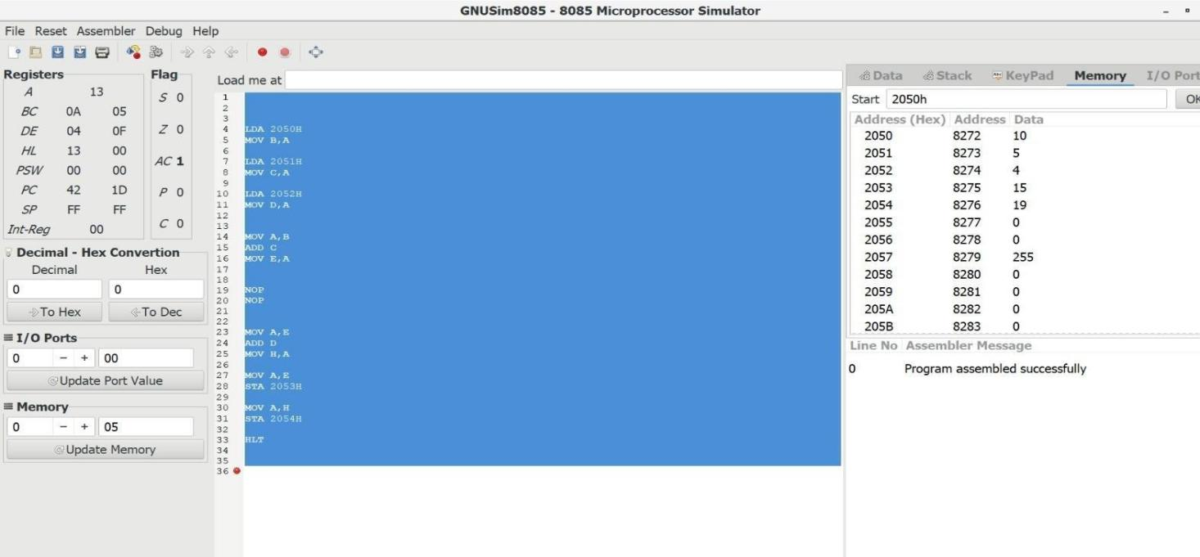

Code of Conduct:

I S.PRITHIKA(192512432)certify that this submission is my original work and that I have adhered to the guidelines specified for this assessment.I understand that any violation of academic integrity rules will result in disciplinary action.
Signature of the student:

MARKS ALLOCATION

 | Problem Understanding  (20%) | Method Selection (20%) | Solution Process  (25%) | Accuracy of Calculation  (20%) | Interpretation of Results  (15%)
Q1
Q2
Q3
Q4
Q5

RUBRICS FOR CALCULATION:

Criteria | Weightage | Level 4 – Exemplary | Level 3 – Proficient | Level 2 – Developing | Level 1 – Beginnin g
Problem Understanding | 20% | Clearly interprets problem, identifies all parameters and requirements accurately | Understands problem with minor gaps | Partial understanding; misses key elements | Misinterprets or unable to understand problem

Method Selection | 20% | Selects most appropriate method/formula with  strong justification | Selects correct method with minor errors | Inappropriate or partially correct method | Unable to select method
Solution Process | 25% | Logical, systematic steps with correct approach throughout | Mostly correct steps with minor mistakes | Disorganized steps; multiple errors | No clear process
Accuracy of Calculation | 20% | All calculations accurate; correct final answer | Minor  calculation errors | Frequent errors; incorrect final answer | No valid calculations
Interpretation of Results | 15% | Clearly interprets results with units and engineering relevance | Basic interpretation with minor  omissions | Limited or unclear interpretation | No interpretation

